**Disclaimer:** For this hackathon, we're utilizing two categories of data: either dummy data, which has been created solely for the event's purpose, or publicly available data.

**Task x: Utilise Agentspace as a go-to solution for employee queries**

Agentspace is a unified platform, it brings together search, AI and agents to help you find, understand and act on your enterprise data. In this task you will be using Agentspace as your personalized employee knowledge hub, available 24/7, ready to answer virtually any question you have about the company, processes, and your role within it.

In this task you will:

1. Create an Agentspace application with a Google Cloud Storage data connection
2. Get familiar with Agentspace UI
3. Chat with your data sources
4. Create a no-code agent
5. **Create an Agentspace application and your data store**

Within your project, in the search bar search for AI applications

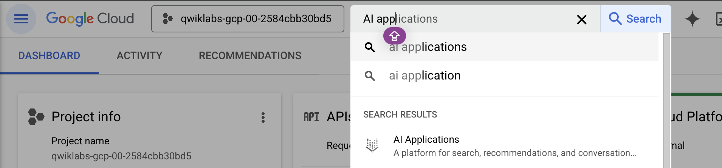

Clink on “Continue and Activate the API”

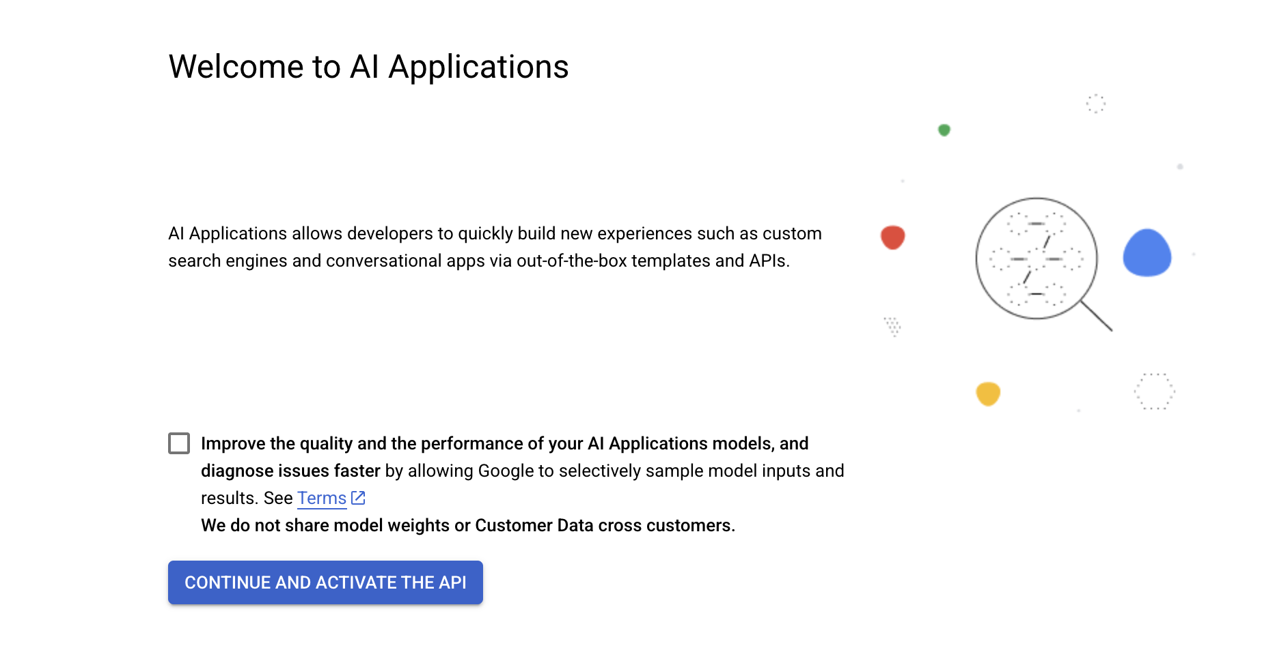

Expect that setting up the environment will take around 1 minute

To create the application click on “Create” on the Agentespace box.

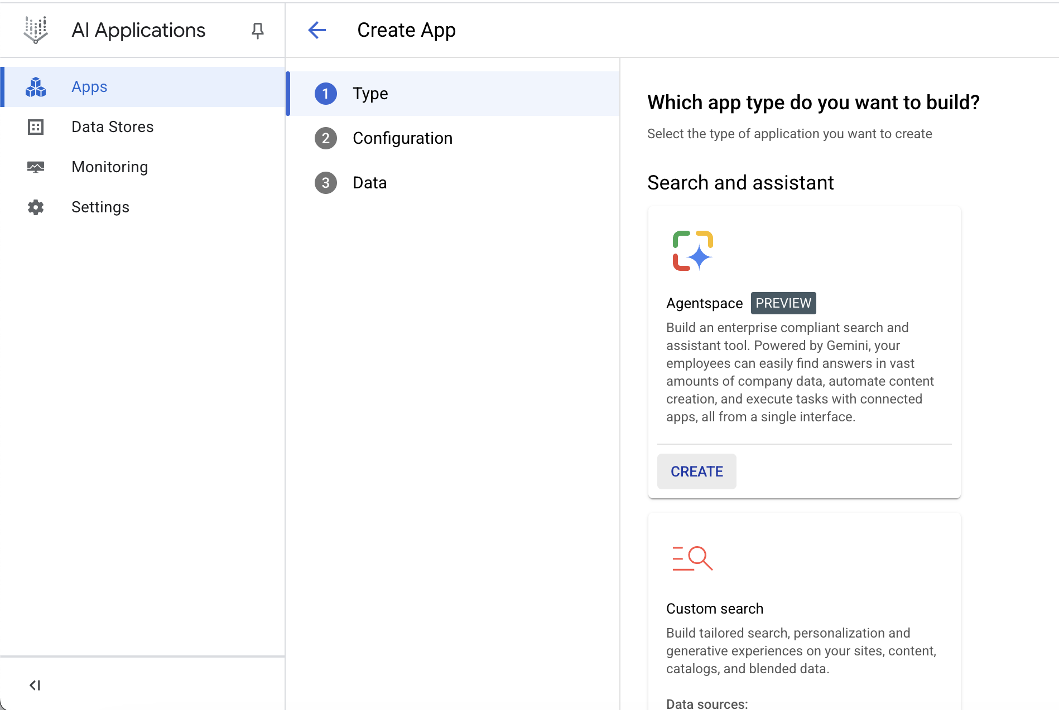

In the Configuration provide a nama for your application and a company name.

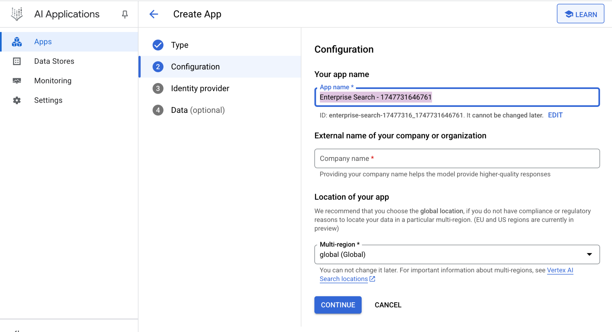

In the identity provide select “Google Identity Provider”

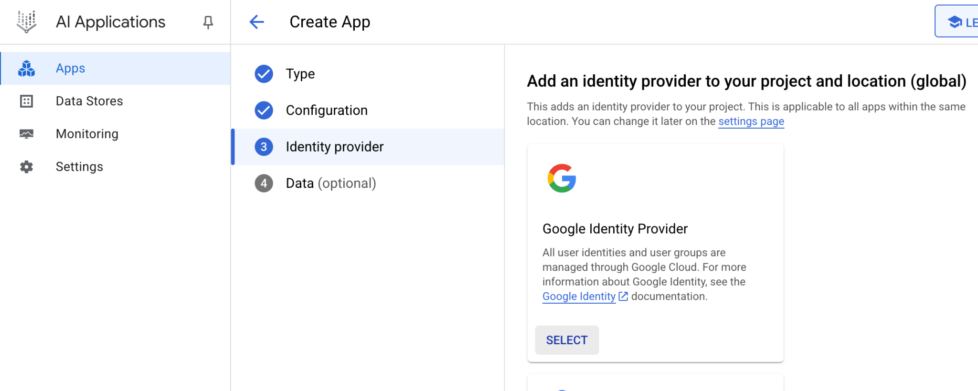

In the data select “CREATE DATA STORE”

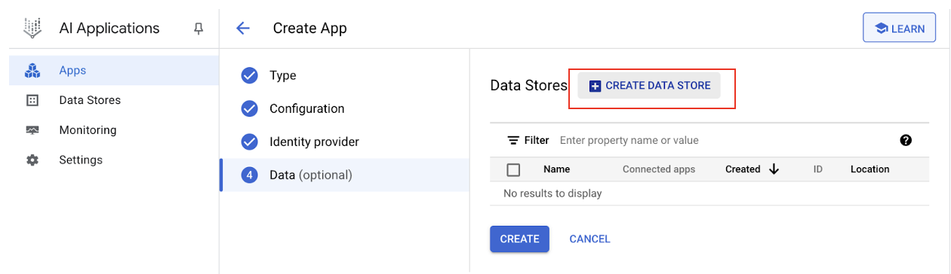

Select Cloud Storage

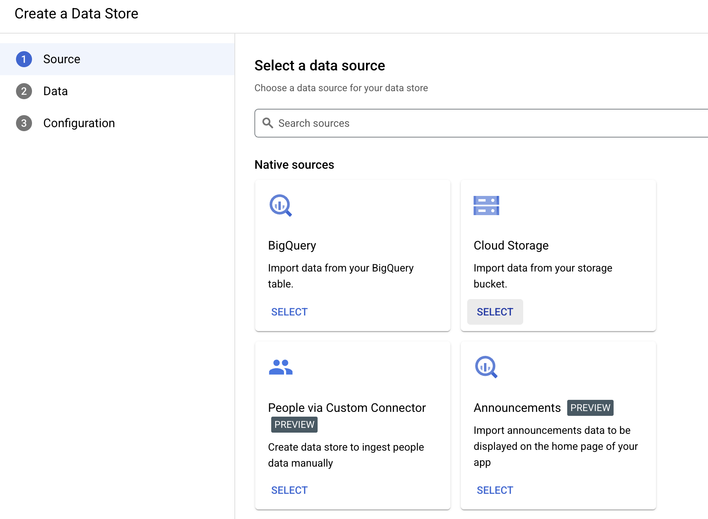

In the configuration leave everything as default.

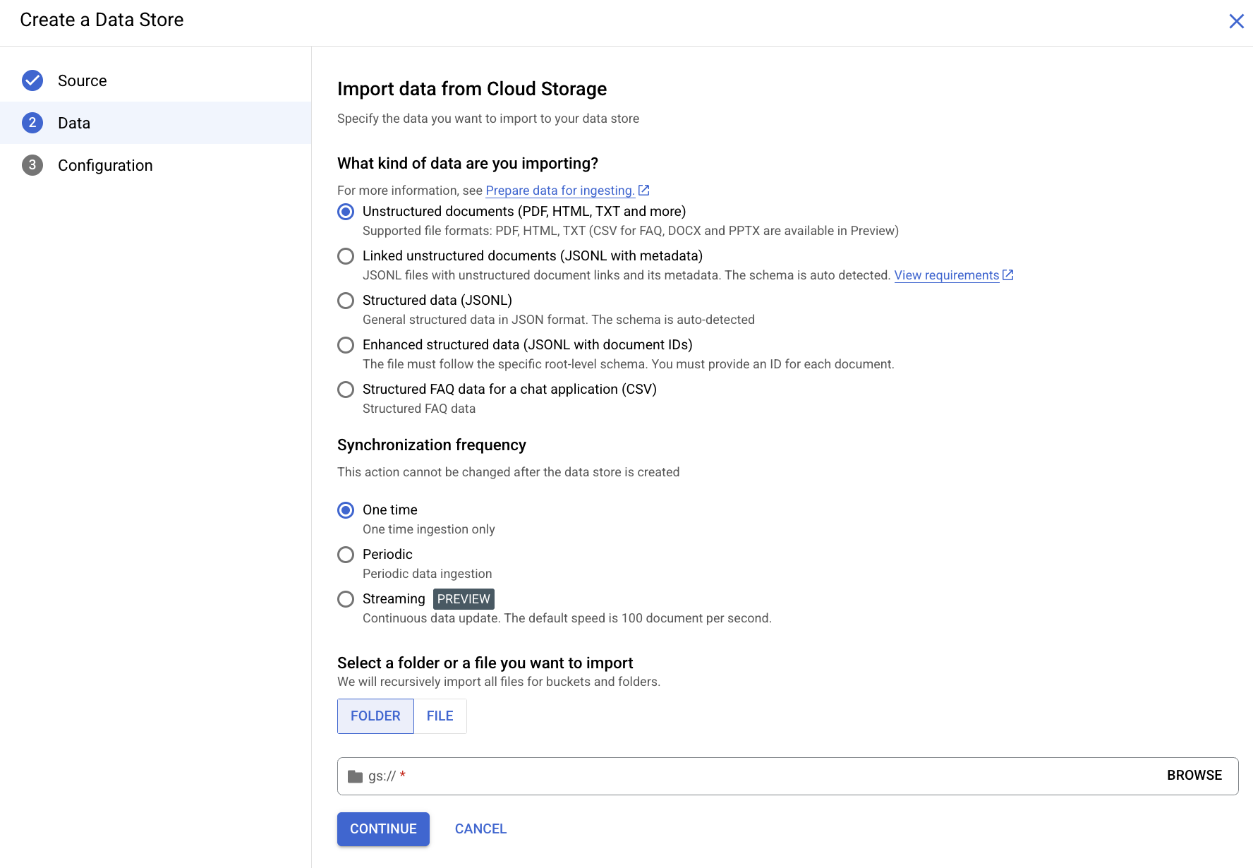

Creating a data store using Google Cloud Storage connection, requires a google cloud storage bucket, which we will create in a second tab.

Copy the link from your current browser and paste it in a new tab. In the search bar search for “Cloud Storage”

Create a bucket as shown below

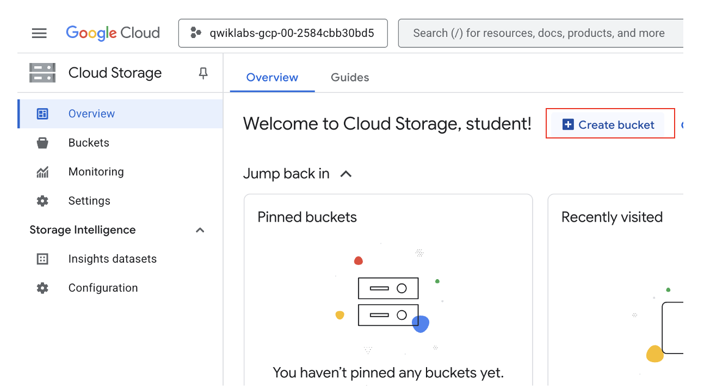

Provide a name, leave everything else as default and select create

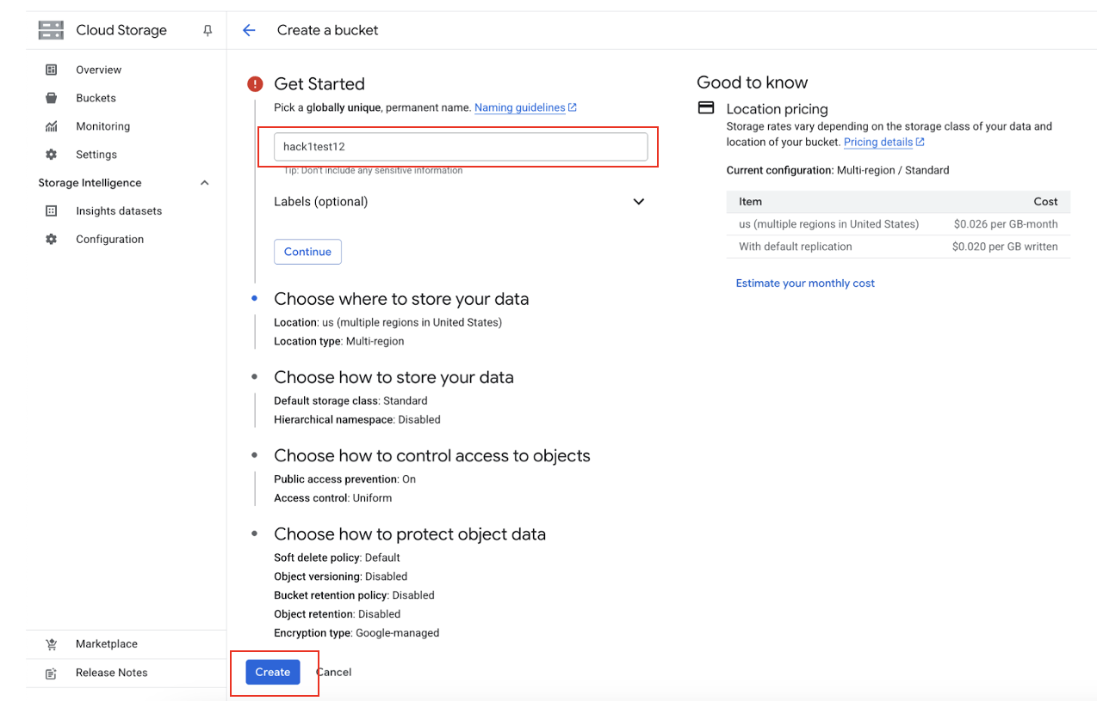

Once your bucket is created, upload files. These files will be your knowledge base utilised in the Agentspace application

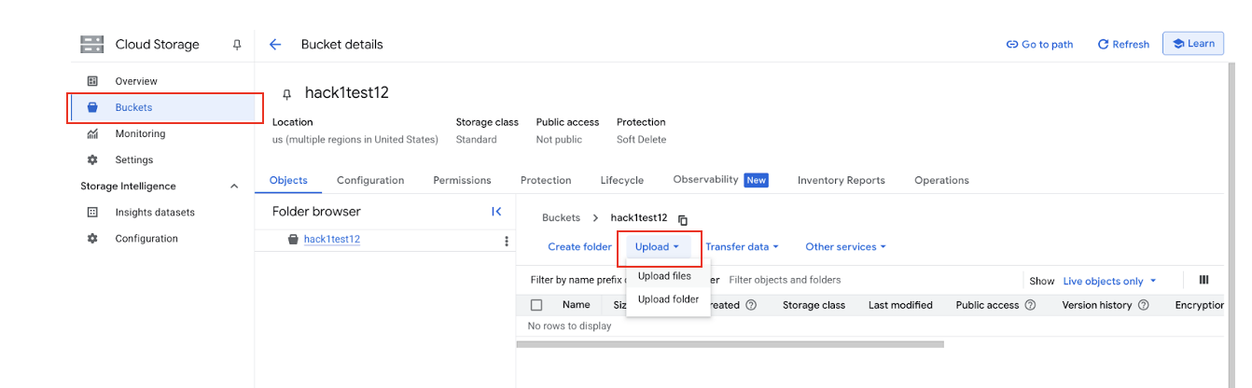

Upload data sets –Add (data sets about employee productivity) - these data should be stored in public bucket

Now that you created your bucket and you have uploaded your data sets, you need to link this data store in your Agentsapce app.

in the “configuration” tab you will find the “gsutil URI”

Copy this link

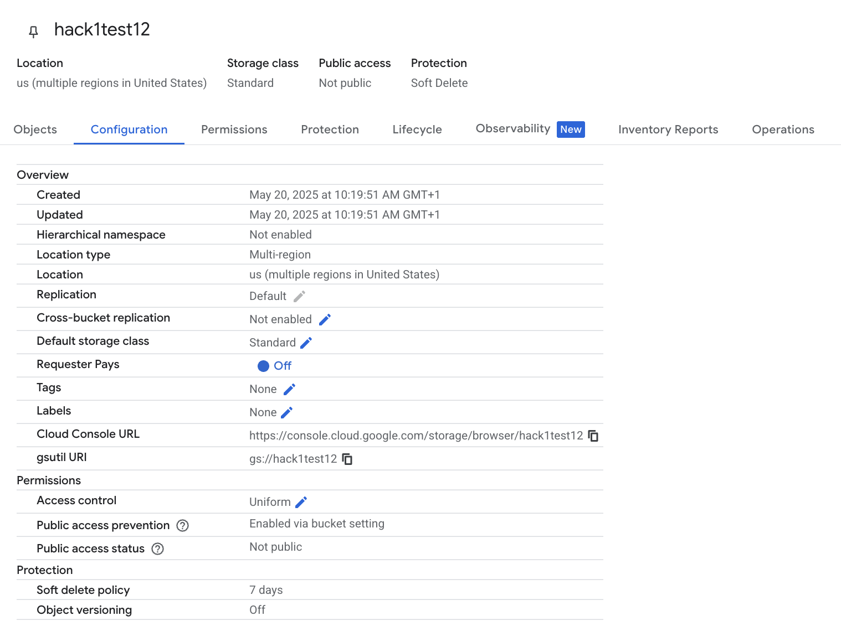

Copy the “gsutil URI”

Paste this in your Agentspace “Data” tab

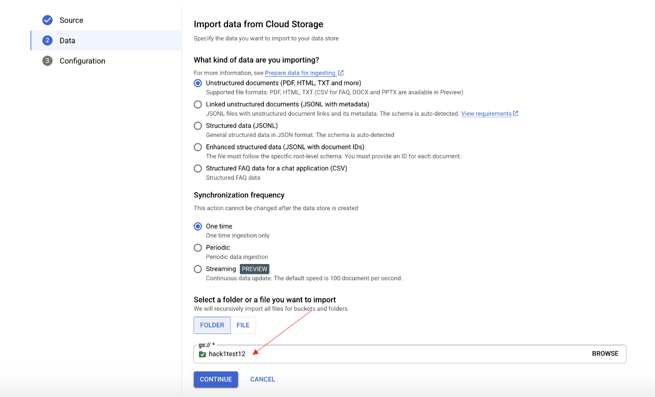

In the configuration add a “Data store name” and click on create.

Your data store is now created and you should see it listed in your “Data Stores” tab in your “AI applications.

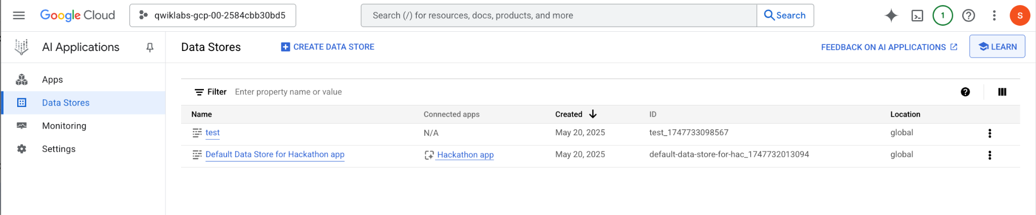

You have now successfully created your Agentspace application. You can view your application listed in your Apps within **AI Applications**.

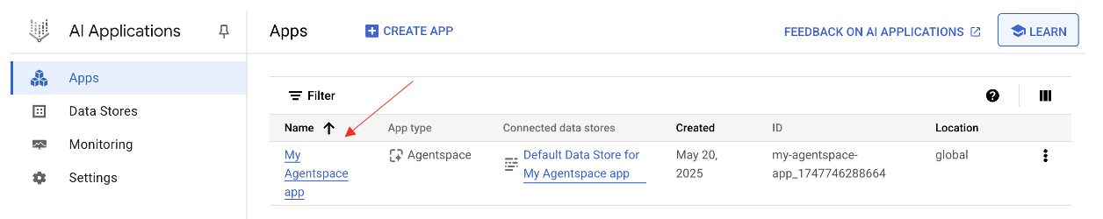

In order to **launch your application**, click on your application’s name.

Then navigate to the Integration tab.

Copy the link to your web application and paste it in a new window.

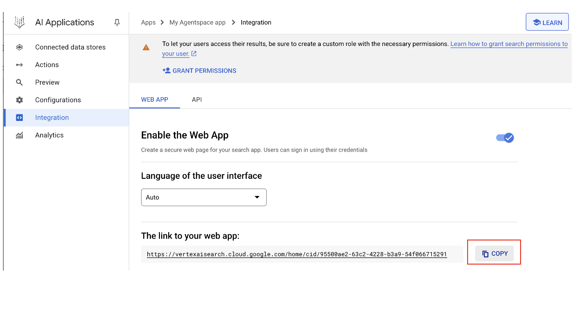

1. Spend some time to familiarise with Agentspace homepage.

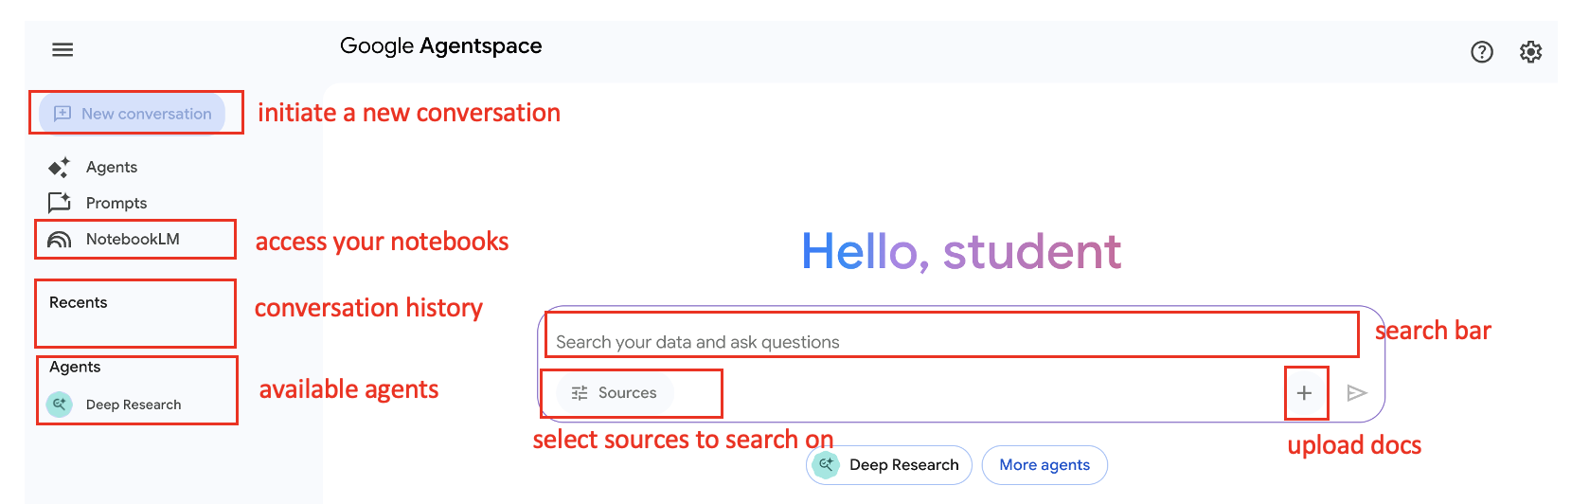

1. Chat with your data sources and explore the search capabilities. Use Agentspace as your employee assistant. Examples of questions:

* **New Employee Onboarding Queries.**
* What should I expect on my first 60 days of onboarding?
* Key Contacts I need for my onboarding?
* **Queries about Internal tools, operations or support.**
* Is there a shared drive to access the Expenses policy?
* What is the IT Support Phone number?
* **Queries about organizational structure, projects, and key initiatives, helping you connect the dots.**
* Who is Emily's White line manager?
* What GPON stands for?
* Project Sponsor for Billing System Upgrade project?

1. Create a no-code agents

Agentspace excels at helping employees quickly find, understand, and act on enterprise data, saving everyone significant time. But you can also create a no-code agent specialized for your specific domain's tasks.

To create a no-code agent with Agent Designer In the app navigation menu, go to **Agents**.Click **Create Agent**.

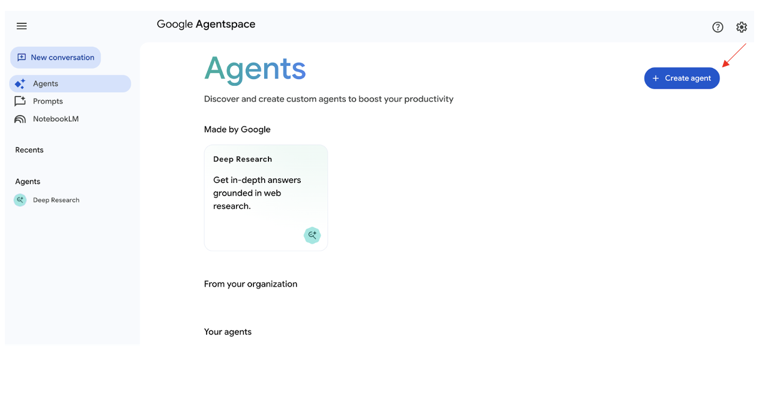

On the **New agent** page, add a name, goal and instructions to the editor:

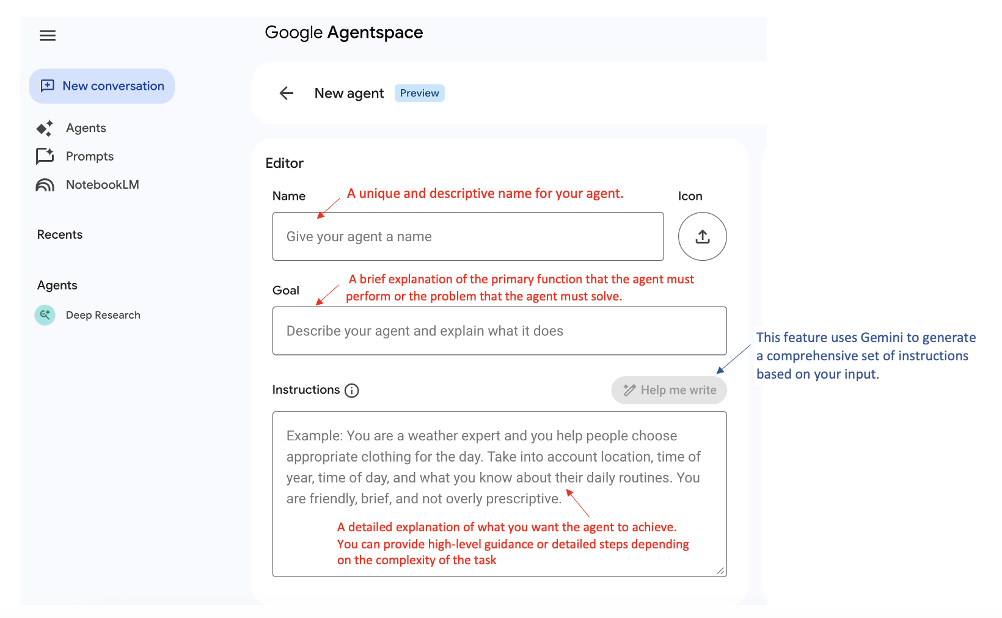

Lets create a **Marketing Assistant Agent** that creates images for marketing campaigns

* **Name:** EE Marketing Agent
* **Goal:** Create images incorporating branding information included in instructions
* **Instructions:** Generate images for telco marketing campaigns. The visuals should incorporate a strong purple color scheme and utilize various British landscapes and landmarks as backgrounds.
* Click Save.
  + The agent is added to your Agents gallery in the Your agents section. The agent also appears in the app navigation menu under your listed Agents.

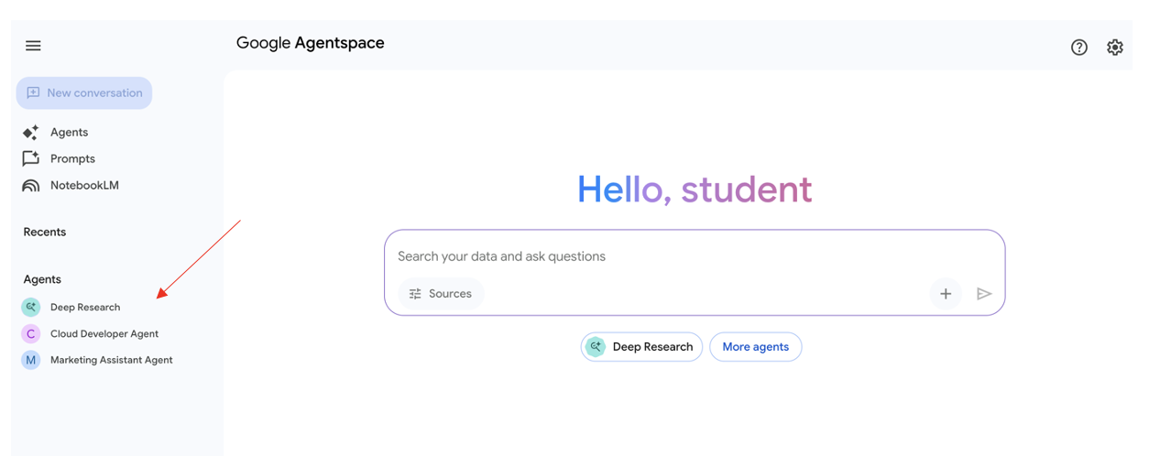

* + Select your agent and ask a question
  + **Example question:** Create an image of a customer talking on their phone.

Repeat the same steps to create a Cloud Developer Agent that writes code for you

* **Name:** Could Developer
* **Goal:** Create SDKs from API documentation.
* **Instructions:** You are a developer that creates SDKs from API documentation. If you are not provided with specific documentation, use available only documentation. Provide code in python programming language
  + Select your agent and ask a question
  + **Example question:** Provide python code for creating an sdk using Google Translate API?

**Task y: Utilize NotebookLM as your primary learning environment to understand the core concepts of Agent Development Kit (ADK).**

**Prerequisite 1:** The prerequisite for this task is to have already created an Agentspace app. This is because you will access NotebookLM *through* Agentspace.

Prerequisite 2: Get a subscription for NotebookLM Enterprise

[**https://cloud.google.com/agentspace/notebooklm-enterprise/docs/set-up-licensing**](https://cloud.google.com/agentspace/notebooklm-enterprise/docs/set-up-licensing)

In the Google Cloud console, go to the Agentspace > Settings > License page.

Select “ADD SUBSCRIPTION”

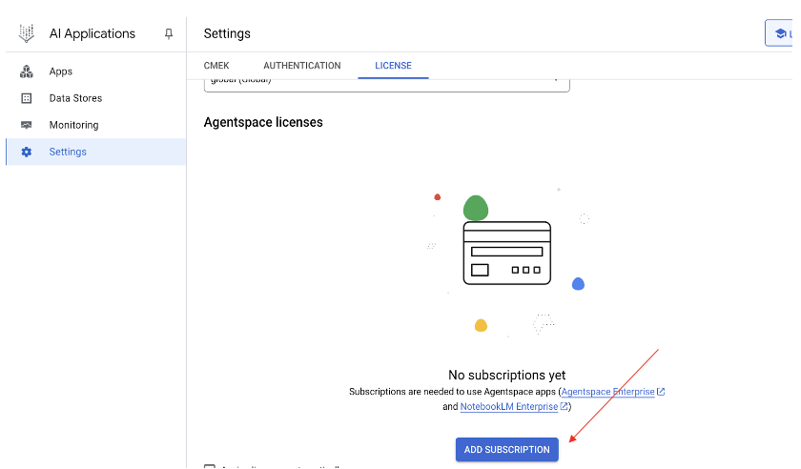

Select the free trial for NotebookLM Enterprise.

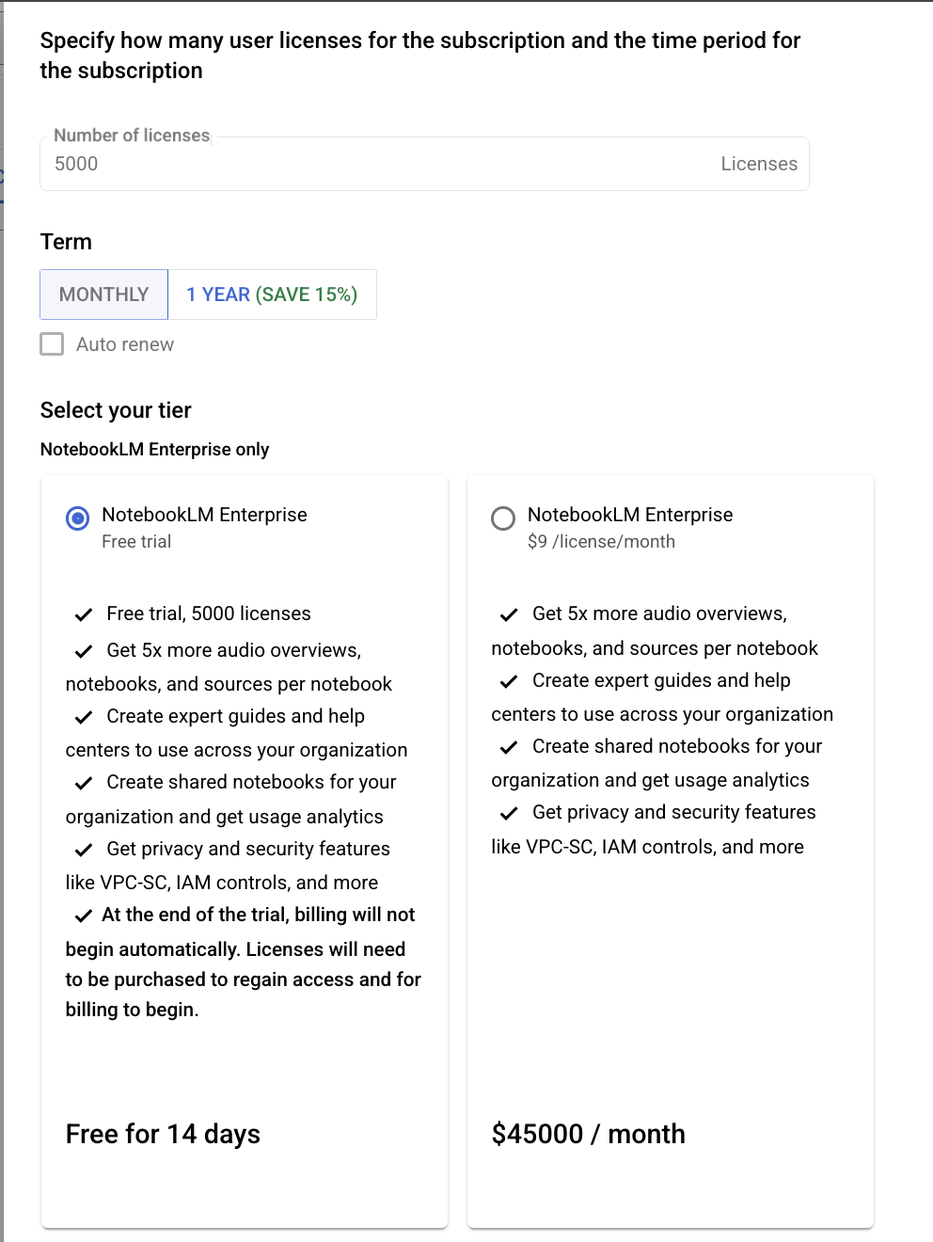

Click add and select “CONFIRM”

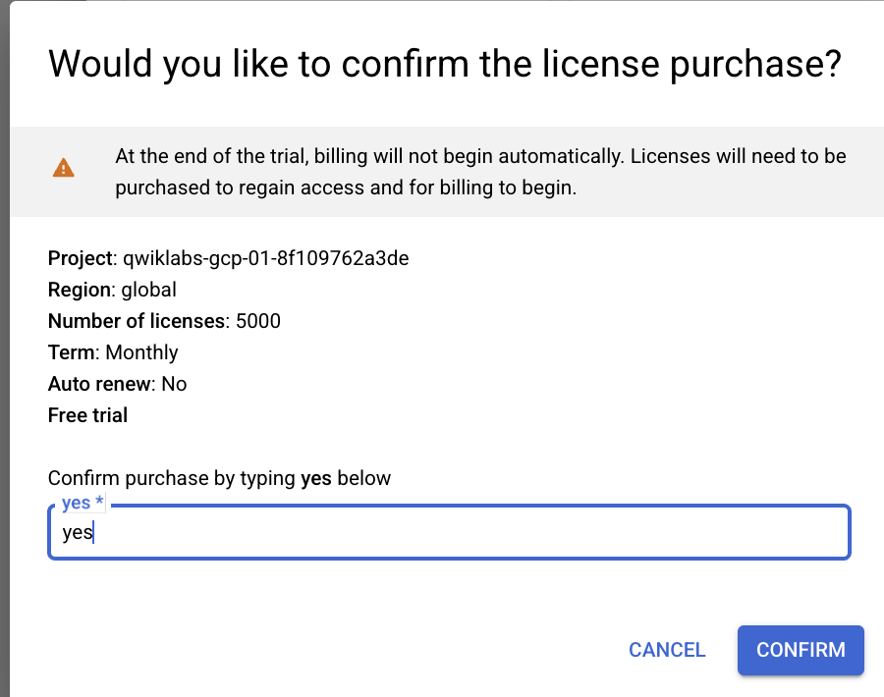

**You should now have access to NotebookLM!**

With NotebookLM, you can upload up to 300 different sources into a single notebook, allowing you to centralize and analyze vast amounts of information. The primary features allow you to chat with your data sources, enabling you to ask questions and receive answers based on the information you've uploaded, plus you can automatically generate audio content.

In this task you will:

1. Create a notebook to explore the topic “Core concepts of Agent Development Kit (ADK)”
2. Chat with your data sources
3. Create a briefing document
4. Create a mindmap
5. Create a customized audio overview

* **How to access Notebook:**

From your Agentspace application, in the left hand menu navigate to notebookLM

1. **Create a new notebook and upload your data sources**

In the “Sources” tab select “Add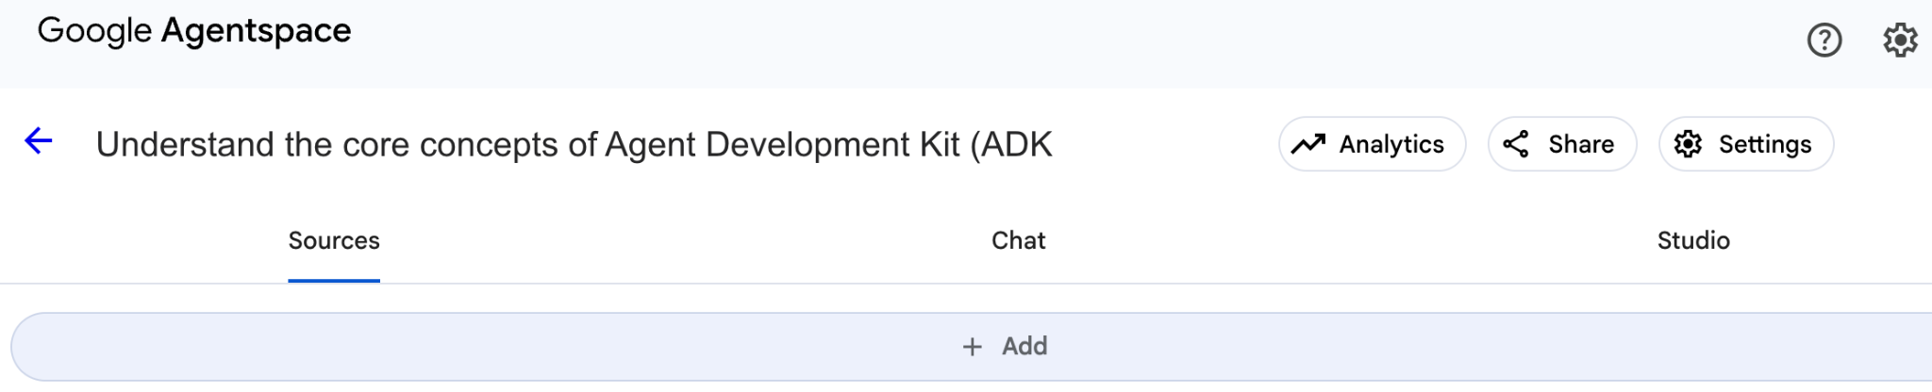

Add the below data sources:

* [**https://google.github.io/adk-docs/**](https://google.github.io/adk-docs/)
* [**https://cloud.google.com/vertex-ai/generative-ai/docs/agent-development-kit/quickstart**](https://cloud.google.com/vertex-ai/generative-ai/docs/agent-development-kit/quickstart)
* [**https://dev.to/timtech4u/building-ai-agents-with-google-adk-fastapi-and-mcp-26h7**](https://dev.to/timtech4u/building-ai-agents-with-google-adk-fastapi-and-mcp-26h7)
* [**https://www.youtube.com/watch?v=bPtKnDIVEsg**](https://www.youtube.com/watch?v=bPtKnDIVEsg)
* [**https://codelabs.developers.google.com/instavibe-adk-multi-agents/instructions?hl=en#0**](https://codelabs.developers.google.com/instavibe-adk-multi-agents/instructions?hl=en#0)
* [**https://medium.com/google-cloud/build-a-rag-agent-using-google-adk-and-vertex-ai-rag-engine-bb1e6b1ee09d**](https://medium.com/google-cloud/build-a-rag-agent-using-google-adk-and-vertex-ai-rag-engine-bb1e6b1ee09d)

1. **Chat with your data sources**

In the “Chat” tab use the search bar to ask your questions. For example:

* What is ADK used for?
* What are the core architectural components and design principles of the ADK framework?
* What are ADK workflow agent types?
* What is A2A used for?
* What functionalities do MCP servers implement?
* How do A2A and MCP differ?
* What is Agent Engine useful for?

1. **Create a briefing document**

Navigate to the “Studio” tab to create a briefing doc

1. **Create a mindmap**

Navigate to the “Chat” tab to create a mindmap.

1. **Create a customized audio overview. Join the discussion and ask a question.**

Navigate to the “Studio” tab to generate an audio.

Click “Customise” to customise the generated audio

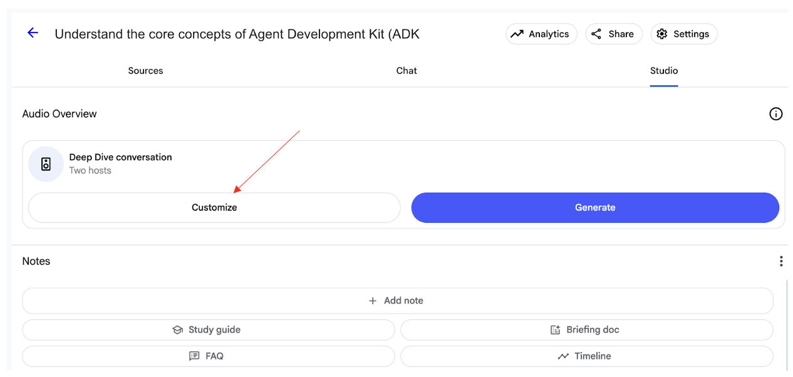

Expect this will take a few minutes.

Once your audio is generated you can listen to the audio. You can also use the “Interactive mode” to interrupt and ask a question. 